Bonjour,

Afin de vous permettre de répondre à la Consultation de l’ECHA de façon rapide et efficace, la Chambre Syndicale Nationale du Vitrail avec le soutien de la fédération du Cristal, du Verre et du Vitrail et de l’Institut du Verre, vous transmet ci-dessous la notice méthodologique pour répondre à la consultation en cours.

Les textes en rouge sont à copier-coller dans les encarts prévus à cet effet. Il vous suffit de suivre la notice méthodologique. Nous avons traduit pour vous les éléments à comprendre pour répondre.

1/ Vous rendre sur la consultation :
Lien vers la consultation
https://www.echa.europa.eu/recommendation-for-inclusion-in-the-authorisation-list

2/ sélection de la consultation :
Cliquez sur le bouton « Details » a droite de la ligne dont le nom est « LEAD »

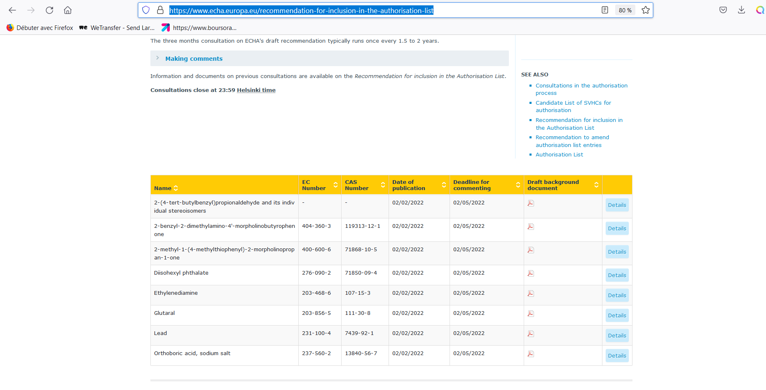
Une page s’ouvre
Cliquez sur les mots en bleu « Give Comments » à droite de la ligne « Link to form for consultation on ECHA’s draft recommendation »
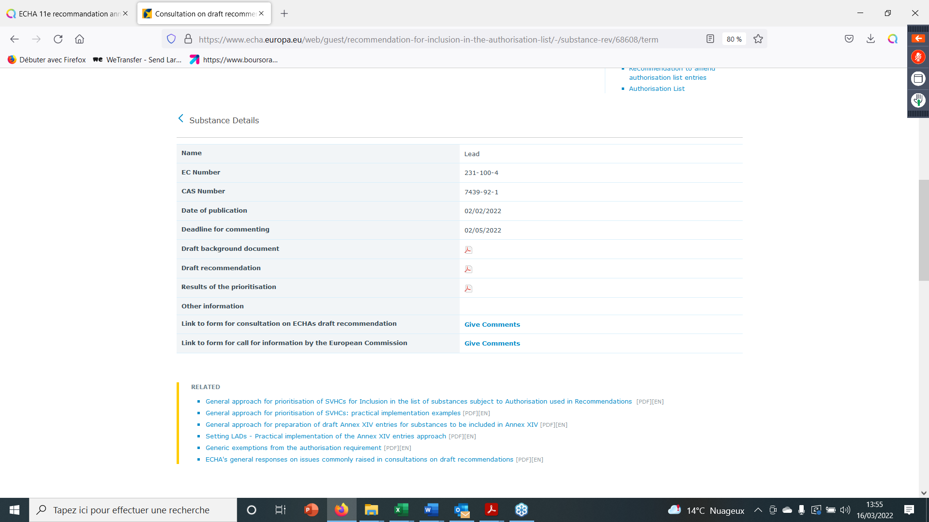
Demande d’information de la Commission UE
Consultation publique de l’ECHA

Une fois sur la page vous disposez de plusieurs encarts :

Encart I. Personal Information (Informations personnelles)
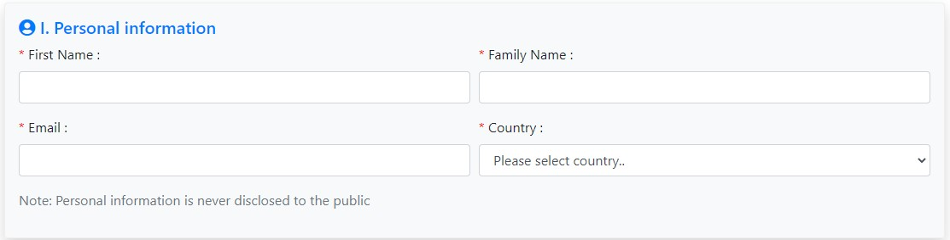Remplir :
- Prénom (First Name),
- Nom de famille (Family Name),
- E-mail
- Sélectionner dans le menu déroulant votre pays (Country)

ALLER A LA PAGE SUIVANTE

Encart II. Organisation (Organisation)
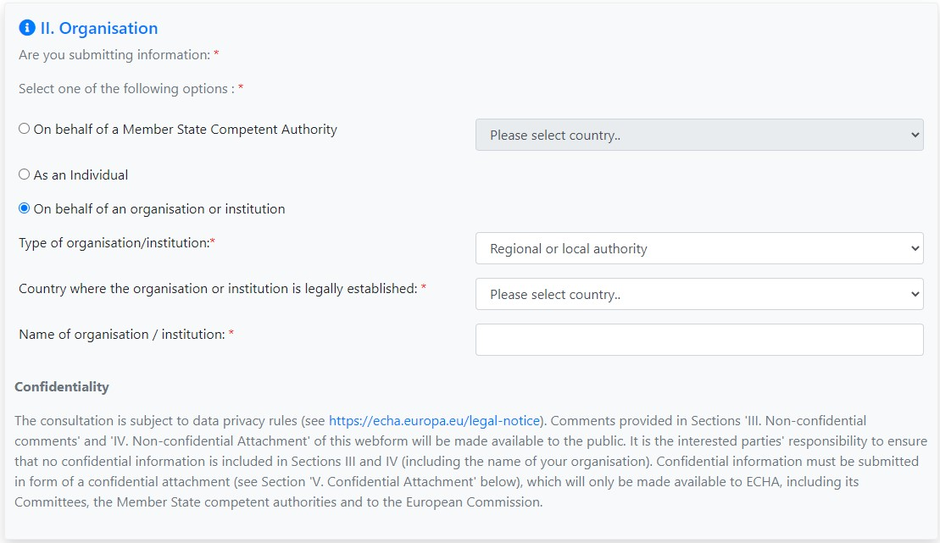Attention les menus déroulant en face des sélections ne sont accessibles que si vous avez sélectionner l’option en face du menu déroulant
- Si vous répondez en tant que citoyen européen
  - Cliquez dans la bulle blanche devant « As an individu »
- Si vous répondez en tant qu’entreprise ou association, ou organisation syndicale
  - Cliquez dans la bulle blanche à la gauche de « On behalf of an organisation or institution »
  - En face de « Type of organisation/Institution » sélectionnez la nomenclature adéquate :
    - Entreprise « Compagny »
    - Autorité Nationale « National Autority »
    - Autorité locale ou régionale « Regional or local autority »
    - Institution Academique « Academic institution »
    - Organisation non gouvernementale nationale « National NGO »
    - Organisation non gouvernementale international « International NGO »
    - Association d’Industrie « Industry or trade association »
    - Institution Européen « European institution »
    - Organisation internationale « International organisation »
    - Syndicat Professionnel « Trade union »
    - Autre contributeur « Other Contributor »
  - Sélectionner votre pays « Country » dans la liste déroulante

ALLER A LA PAGE SUIVANTE

Encart III. Non-confidential comments on ECHA’s draft recommendation (Commentaire non confidentiel sur le projet de recommandation de l’ECHA)
Priorisation and general issues (Priorisation et questions générales) :
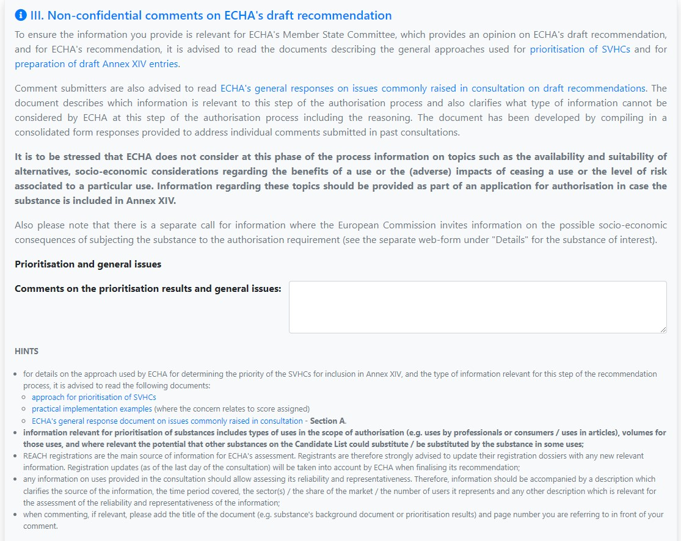Ne rien mettre

ALLER A LA PAGE SUIVANTE

Transitional arrangement (Disposition transitoire) :
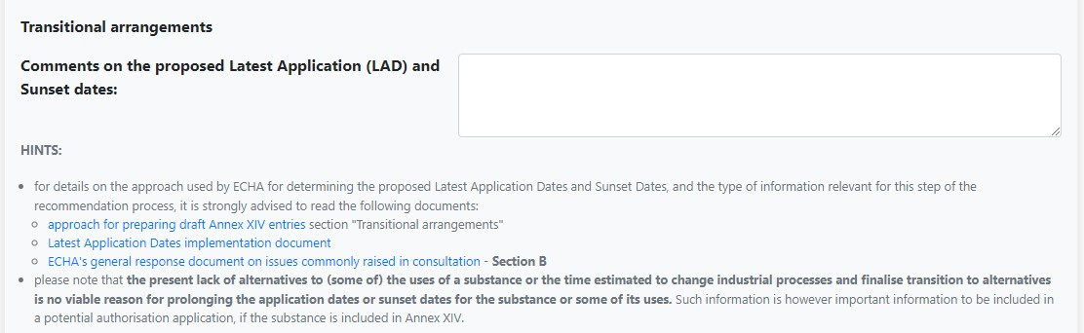- Copier-coller le texte ci-dessous en anglais :
  - If ever the lead had to be registered, the deadlines for the stained glass window are much too short
  - Traduction : Si jamais le plomb devait être inscrit, les délais pour le vitrail sont beaucoup trop courts

Uses exempted from the autorisation requirement (Usage exempté de la procédure d’autorisation) :
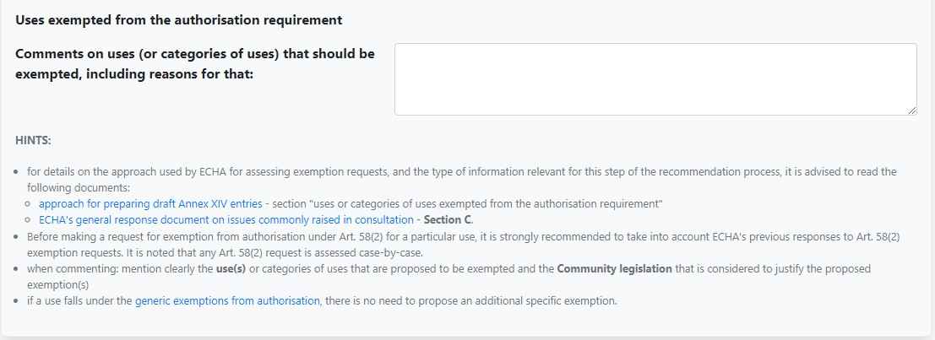- Copier-coller le texte en rouge de la lettre dans son intégralité en anglais que vous trouvez ci-après (vous avez reçu en même temps que la notice méthodologique la version française) :

CONTRIBUTION TO THE PROPOSAL MADE BY ECHA TO INCLUDE LEAD IN ANNEX XIV (AUTHORIZATION PROCESS) IN THE FRAMEWORK OF REACH ISSUED
BY THE FRENCH NATIONAL TRADE UNION OF STAINED GLASS

- Context

ECHA has proposed the inclusion of lead in Annex XIV of the REACH regulation via its draft 11th recommendation. A consultation is organized by ECHA in order to collect the position of stakeholders on this project. In this context, the National Trade Union Chamber of Stained Glass (CSNV) wishes to express its opposition to this project which, if implemented, would lead to the suppression of a thousand-year-old know-how and would condemn whole sections of European heritage.

Created in 1894, the CSNV is the French professional organization bringing together 1,200 professionals who create and restore stained glass. These professionals form a sector whose influence is inversely proportional to its size; France has the largest area of ​​stained glass in the world.
A workshop has an average of 2 employees and an average turnover of around 100 k€/year.

However, the know-how of master glassmakers is measured less in euros than in wealth induced in terms of tourism and local development, but also in intangible and historical terms.

Lead in the form of metal has been used for more than a thousand years by stained glass artists to join and solder the pieces of glass forming a stained glass window.

DESCRIPTION

1. Stained glass is an assembly of glasses held together by H-shaped lead. Lead is the only material allowing, due to its malleability, a precision crimping that no other material offers today.

2. Heritage restoration is 70% part of the activity of our branch and if we can imagine using another glass assembly agent for creations, this is not the case for conservation and restoration which must, out of respect for the history of art and for the integrity of the works of art on which we work, use the original materials.

3. In terms of creation, the surfaces treated between secular and religious are about 50/50.

4. Between responding to a call for tenders and carrying out the work, several years may pass (typically 5 years).

- ARGUMENTS AGAINST THE INSCRIPTION OF LEAD IN ANNEX XIV

a) There is no substitute for lead

There are several ways to crimp glass:

• Glass 2 to 5 mm thick tinted in the mass:

1/ H-shaped lead crimp welded at each intersection with an alloy composed of 40% pure lead for 60% pure tin. This working method is the only one known to date to guarantee the integrity and durability of stained glass works of art, some of which were made in the Middle Ages and are still admired today.

2/ Tiffany technique
The lead rails are replaced by self-adhesive copper films placed around the entire periphery of the glasses. Solder (40% pure lead alloy for 60% pure tin) is used to join the glasses. This working method cannot be transposed to restoration work.
The adhesive copper tape being distributed over the entire surface of the glass, the soldering operations over the entire surface of the tapes (and not at the point of intersection as for lead assembly) involve a very significant exposure of the glasses to heat and risks damaging old glasses by creating thermal shocks and causing multiple breaks on the glasses. The repair of stained glass windows assembled with copper is made extremely complex or even totally impossible on large surfaces because of the difficulty in extracting the pieces of glass from their welding sheaths. This process consists of melting the tin around the entire contour of the piece of glass set with copper in order to extract it. On the other hand, the pieces of glass that make up a lead stained glass window have been calibrated in order to take into account the necessary reserve corresponding to the thickness of the heart of the lead in H. The work of cutting the glasses for the copper assembly does not take no reserve account, the pieces of glass are arranged edge to edge before being welded and not assembled as with lead. We cannot therefore transpose the Tiffany method on stained glass windows designed with lead.

• Glasses from 1 cm to 2.5 cm thick

For these glasses only, which are not stained glass but glass slabs, the use of a two-component epoxy resin loaded with a mineral mass is possible.
This method cannot be transposed with thinner glasses of 2 to 5 mm as it is used in the stained glass method.

- Colored glass tinted in the mass, the only material allowing this work of light and color
The particularity of stained glass is its assembly of colored glass tinted in the mass. These glasses allow the work of light and color like no other material. The assembly of small parts requires flexibility of the holding network, of which only lead can guarantee working flexibility and durability of at least 100 years.

- Une dangerosité liée à l’utilisation de plomb dans la fabrication des vitraux n’est pas avérée

- Consumer health: there is no consumer exposure. The stained glass windows are supposed to adorn mostly religious monuments. These are ornamental pieces which, once installed, are not subject to manipulation and which we maintain by intervening every hundred years on average in order to replace the oxidized and weakened lead to guarantee the durability of the work. in time and the safety of their owners.

- The volumes concerned underline the specific character of the works of the stained glass artists. Approximately 10,000 m2 of stained glass windows are refilled with lead each year, corresponding to 26 t of lead according to our estimates.
- Worker health protection is framed at national level (in France, limit of 400 and 300 µg/L of blood). The French National Trade Union of Stained Glass has not identified any case of lead poisoning within the stained glass population. Thanks to the implementation of appropriate protocols within our companies and the generalization of the use of PPE, the lead levels in the blood of workers in the sector have dropped considerably and comply with standards.

- Economic and social, environmental, cultural and societal consequences:

Economic and Social :
Economically, this registration would harm a multitude of nearly 1200 VSEs-SMEs with an average of 2 employees, and the destruction of highly qualified jobs whose know-how recognized worldwide are essential for the maintenance of the greatest heritage. stained glass of the world. These companies are too small to bear the cost of producing an authorization application file – average turnover of around €100,000 – and the market is too small for suppliers to take an interest in them.
In addition to the disappearance of nearly 1,200 VSEs and SMEs, and the destruction of jobs, there is a threat in terms of tourism: religious buildings and castles are jewels of European cultural heritage. Can we imagine the Cathedral of Notre-Dame-de-Paris (between 12 and 14 million visitors per year), that of Chartres (more than one million visitors per year) or the Saint-Chapelle (1.3 million visitors per year) without stained glass windows?

Environmental:
Only our specialized craft companies are trained in the maintenance and restoration of stained glass heritage, one of the tasks of which is to disencase and separate the colored glass pieces from the oxidized and worn lead profiles in order to replace them with new lead. During these operations, used lead is systematically sorted and stored for recycling (we achieve a rate of almost 100% recycling of lead), our workshops thus avoid the dissemination of lead in household waste or nature. The know-how of our workshops is essential in the field of recycling lead from old stained glass windows.

Cultural and societal:
These workshops, symbols of French know-how recognized by the State as "Living Heritage Companies", are part of French and European heritage, they contribute to the influence of our culture in the world. Our know-how has been passed down in our workshops since the Middle Ages, almost a seven thousand years.

Stained glass windows used in places of worship, historical monuments and many private or public buildings:
The windows of the churches must be restored every 120 years. France, which has more than 60% of the world's heritage in terms of stained glass windows, must now restore those of the 19th century. The surface of 19th century stained glass windows itself corresponds to more than 60% of all old stained glass windows. They represent an artistic and historical richness. The area of stained glass in France is estimated at more than 90,000 square meters.

If ECHA engages in a process of listing lead in Annex XIV of REACH without discernment and without consideration for the conservation-restoration of our heritage, it would seriously threaten European cultural heritage.

It seems to us at least given the specificities of our sector that in the event of the inclusion of lead in Annex XIV, the use in the context of stained glass should be exempted. A partial exemption of the catering activity alone would significantly reduce the activity and would not make it possible to retain the necessary know-how.

Encart IV. Attachment (additional non-confidential information) to comments on ECHA's draft recommendation (Pièce jointe (informations non confidentielles supplémentaires) aux commentaires sur le projet de recommandation de l’ECHA) 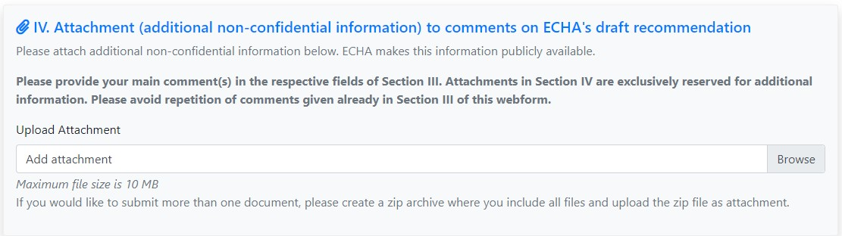
- Cliquez sur « Browse » et sélectionner « 2022.04.25. - CNSV - Réponse consultation ECHA - Contribution Anglais » que nous avons rédigez à cet effet dans le dossier ou vous avez télécharger le fichier PDF que nous vous avons transmis

Encart V. Confidential Attachment to conmments on ECHA’s draft recommendation (Pièce jointe confidentielle aux commentaires sur le projet de recommandation de l’ECHA) :
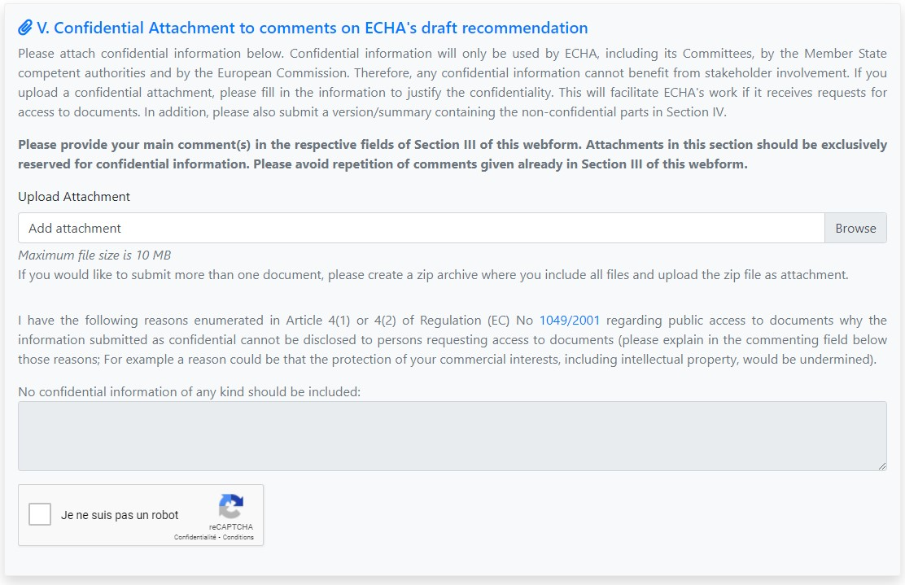
- Si vous voulez transmettre des informations confidentielles spécifique (CA, Nombre de salarié, marges…) vous pouvez le faire ici en transmettant un courrier personnel (Le courrier en Anglais est à privilégier)
- Cliquez sur « Browse » et sélectionner le courrier que nous avons rédigez à cet effet dans le dossier ou vous avez télécharger le fichier PDF que nous vous avons transmis

Enfin, Cliquez dans la case « Je ne suis pas un robot »
Puis cliquez en bas à droite de la page sur le bouton « Submit » pour soumettre votre contribution
La Chambre Syndicale Nationale du Vitrail ainsi que tous ses partenaires vous remercient pour votre contribution. Nous vous rappelons que chaque citoyen européen peut répondre à cette consultation. Nous vous invitons donc à diffuser le plus largement possible les éléments que nous vous avons transmis afin que l’impacte de notre réponse soit la plus grande.

En comptant sur vous,

Jean Mône
Président

